Requirements

| No | Requirement | MoSCoW |
| --- | --- | --- |
| 1 | Students will be able to log in to the application | Must |
| 2 | Students will be able to enter their id to log in | Must |
| 3 | Students will be able to enter their password to log in | Must |
| 4 | Application will only accept the password associated with the entered id | Must |
| 5 | Application will have an admin account | Must |
| 6 | Admin accounts will be able to edit university page | Must |
| 7 | Students will be able to join one university page | Must |
| 8 | Students will not be able to edit university page | Must |
| 9 | Application will have a calendar | Should |
| 10 | Universities will have a specific page on the application | Should |
| 11 | Students will be able to see updates from the university | Should |
| 12 | Admin will be able to add deadline for courses | Should |
| 13 | Admin will be able to edit deadlines for courses | Should |
| 14 | Students will be able to mark deadlines as complete | Should |
| 15 | Admin will be able to enter a form of submission on the deadline | Should |
| 16 | Students will be reminded of deadlines every week coming up to the deadline | Could |
| 17 | Students will be reminded of deadlines daily on the week leading up to the deadline | Could |
| 18 | Students will not be reminded of complete deadlines | Could |
| 19 | Admin will be able to check which students marked the deadline as complete | Could |
| 20 | Student data will be stored in a local database | Must |
| 21 | Admin data will be stored in a local database | Must |
| 22 | Course data will be stored in a local database | Must |
| 23 | Module data will be stored in a local database | Must |
| 24 | Application will not stop when incorrect data entered | Must |

UML Diagrams

# Class Diagram

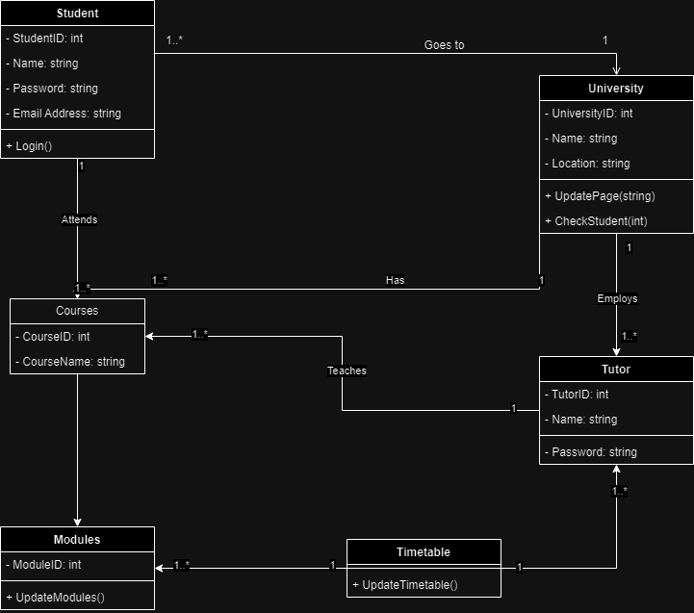

# Entity Relationship Diagram

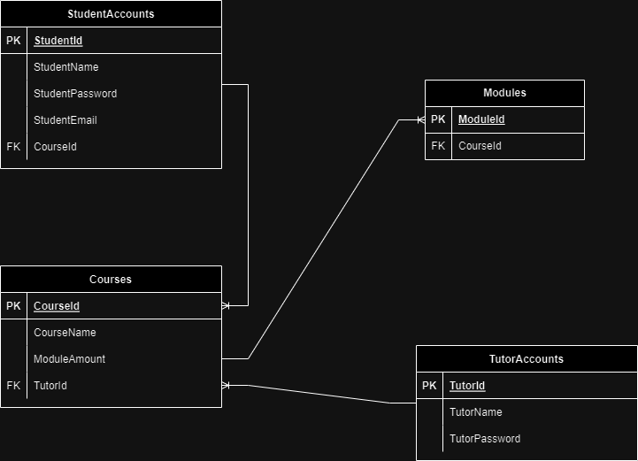

# Use Case Diagram

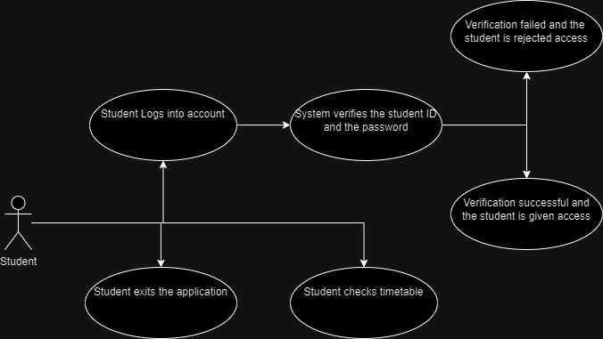

# Sequence Diagram

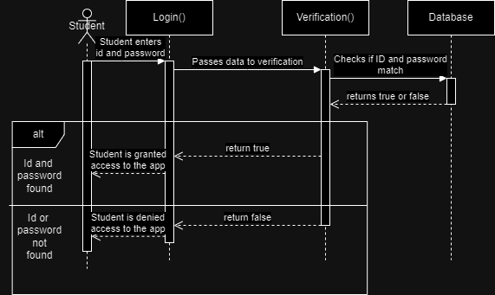

# State Diagram

# 

# Activity Diagram

